Financial Report
- Annual Capital Expenditure by College Category Per Year

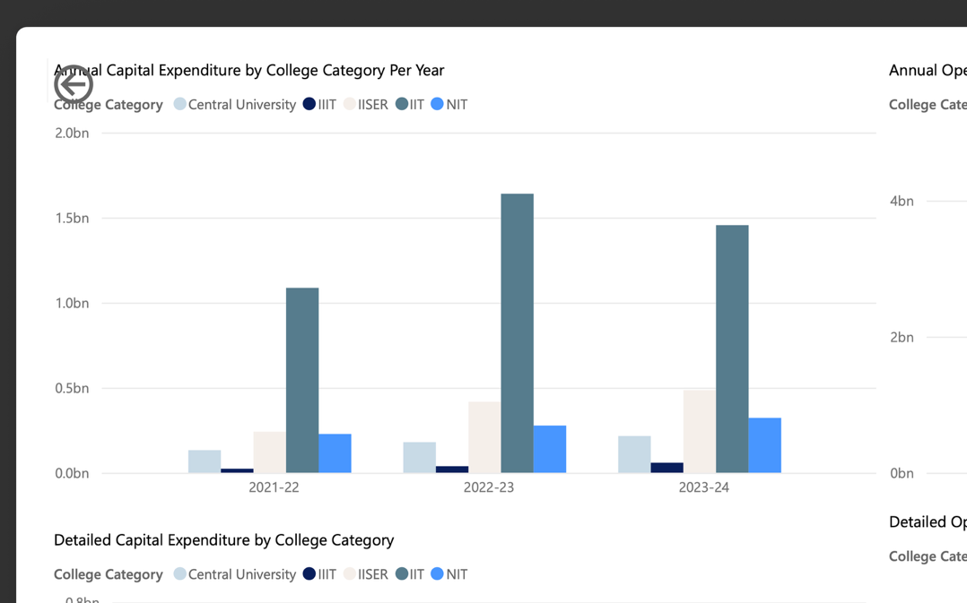

- IITs and NITs consistently have the highest annual capital expenditure, often exceeding 1-2 billion INR per year.
- Central Universities, IIITs, and IISERs spend much less by comparison, indicating larger infrastructure or equipment investments at IITs/NITs.

TREND - Most categories show growth from 2021-22 to 2023-24, with some year-to-year fluctuations.

- Annual Operational Expenditure by College Category Per Year

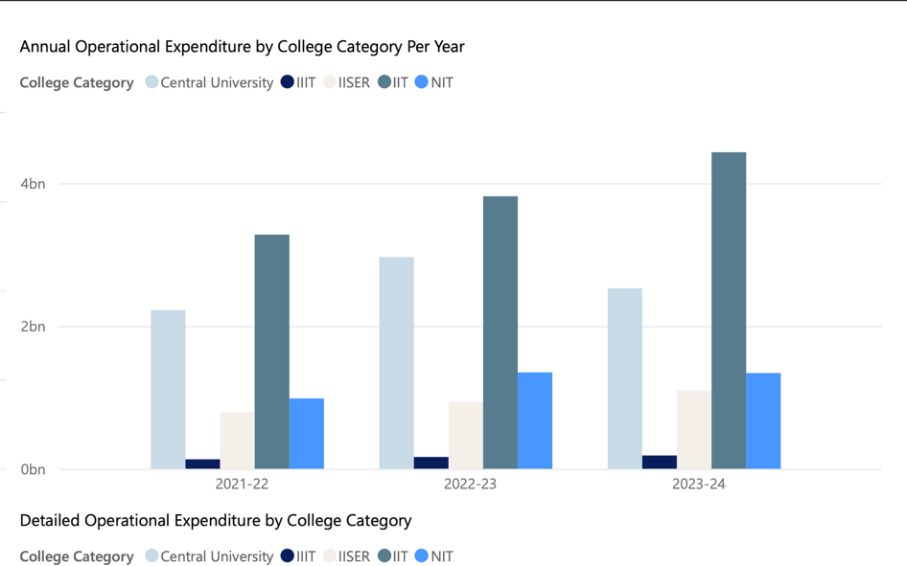

- IITs have operational spends well above 2 billion INR per year, with NITs following.
- Other colleges categories remain significantly lower, suggesting differing scale or operational priorities.

- Detailed Capital Expenditure by College Category

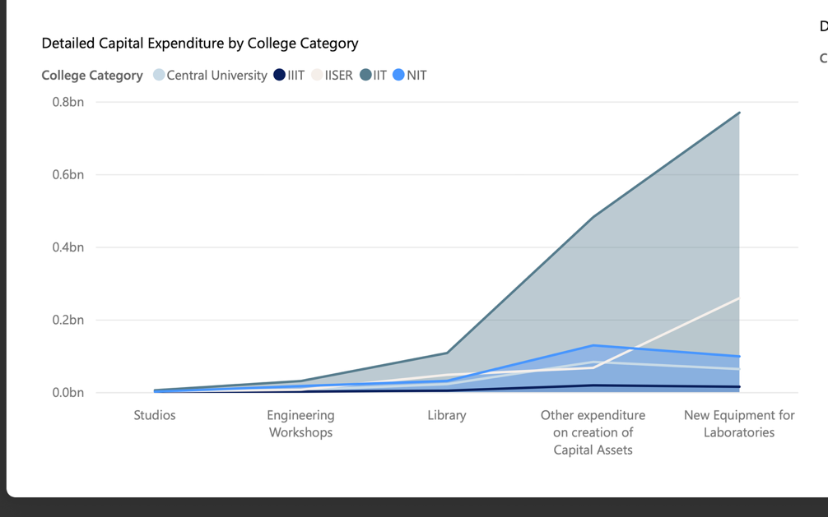

- Libraries and new equipment tend to have the largest capital allocations.
- Studio and workshop spend is variable, sometimes zero in a type/year.

- Detailed Operational Expenditure by College Category

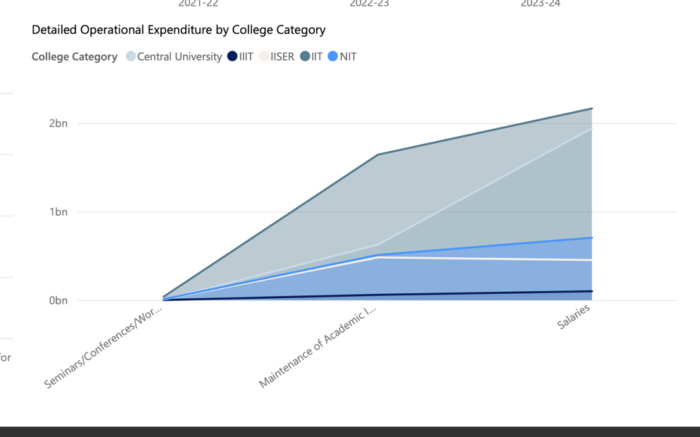

- Salaries are the dominant operational cost in all categories.
- Academic infra maintenance is the next major chunk, with seminars/conferences a small fraction

- Central University

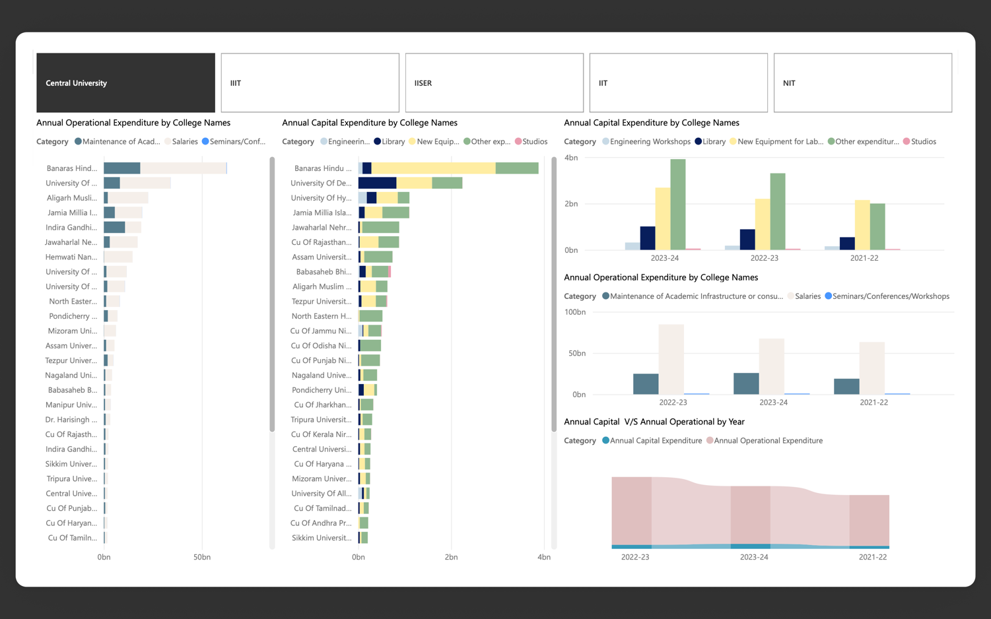

TOP COLLEGES

- Banaras Hindu University
- University of Delhi
- University of Hyderabad

Summary:
- Operational Expenditure: Banaras Hindu University leads, with the majority of funds allocated to salaries, followed by maintenance and a minor portion to seminars/workshops.

- Capital Expenditure: Banaras Hindu University and University of Delhi are top in capital spend, with heavy investments in new equipment for laboratories and libraries. University of Hyderabad shows a more balanced distribution.

- Trend: Both operational and capital expenditures show a steady annual pattern, with operational spend vastly outweighing capital spend.

- IIIT’S

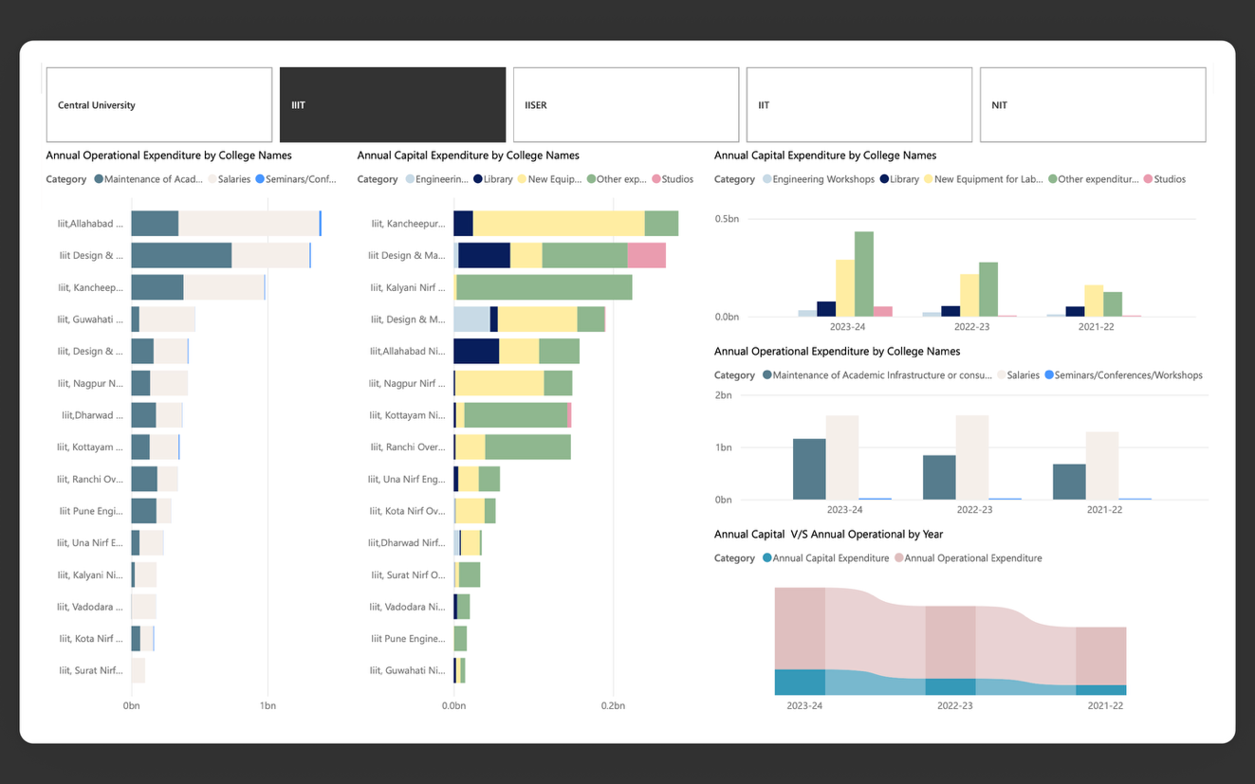

Top Colleges:

- IIIT Allahabad
- IIIT Design & Manufacturing Kancheepuram
- IIIT Kalyani
Summary:

- Operational Expenditure: IIIT Allahabad dominates, mainly in staff salaries and infrastructure maintenance.
- Capital Expenditure: IIIT Design & Manufacturing Kancheepuram and IIIT Kalyani stand out in capital investments, focusing on laboratories, library, and equipment with notable attention to studios and engineering workshops.
- Trend: All top IIITs prioritize research and teaching facilities, with operational outlays primarily for salaries and infra-maintenance.

- IISER

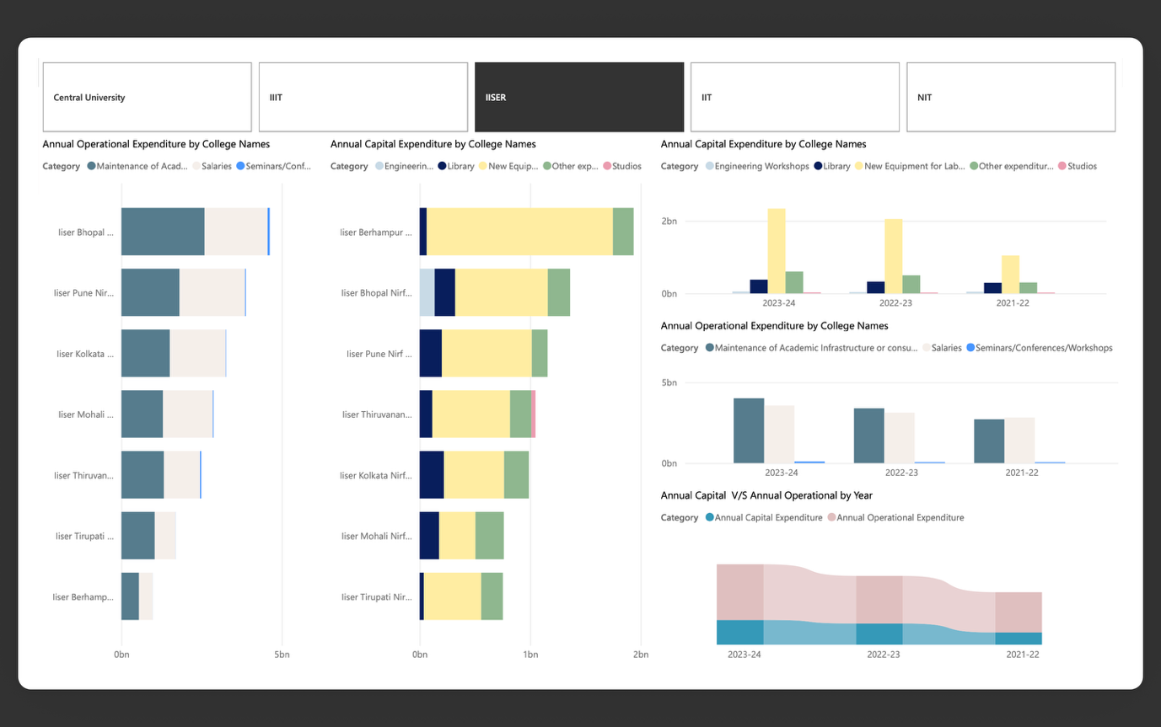

Top Colleges:
- IISER Berhampur
- IISER Bhopal
- IISER Pune
Summary:
- Operational Expenditure: IISER Bhopal leads, allocating funds mainly to maintenance and salaries.
- Capital Expenditure: IISER Berhampur and IISER Bhopal invest heavily in library and laboratory equipment.
- Trend: Capital expenditure is especially library-centric in IISERs, underlining the importance of academic resources. Operational breakdown follows the pattern of salaries and maintenance leading all categories.

- IITs (Indian Institutes of Technology)

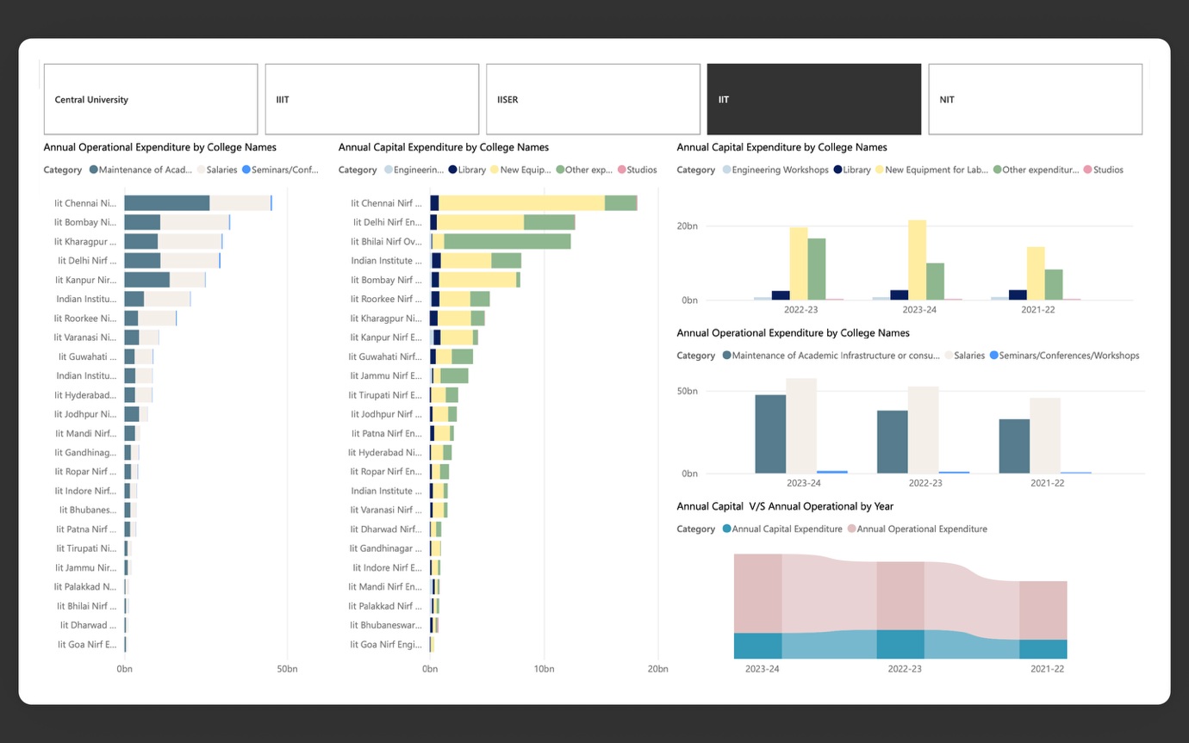

Top Colleges:

- IIT Chennai (Madras)
- IIT Delhi
- IIT Bhilai
Summary:

- Operational Expenditure: IIT Chennai is the leader, with spend dominated by salaries, followed by maintenance of infrastructure.
- Capital Expenditure: IIT Chennai and IIT Delhi both show significant allocations to library and new lab equipment, along with balanced investments across workshops, libraries, and studios.
- Trend: IITs have the highest operational budgets among all categories, reflecting their size, staff strength, and research footprint. Capital investments point to a focus on comprehensive infrastructure.

- NITs

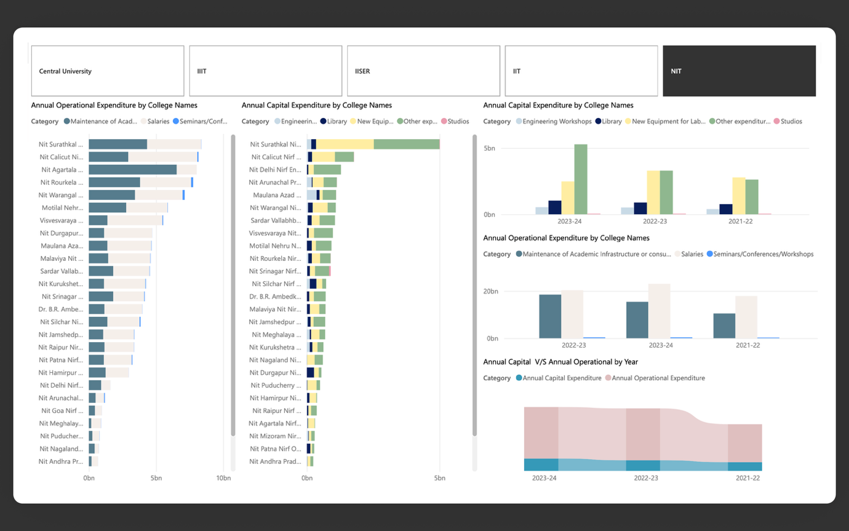

Top Colleges:

- NIT Surathkal
- NIT Calicut
- NIT Agartala

Summary:
- Operational Expenditure: NIT Surathkal and NIT Calicut lead, particularly in salary disbursals and infra-maintenance.
- Capital Expenditure: NIT Surathkal, NIT Calicut, and NIT Delhi stand out with robust spending on new equipment and library enhancements; workshops and other capital assets also see notable investments.
- Trend: Similar to other top institutes, operational spending greatly surpasses capital. The leading NITs maintain strong lab and library funding, suggesting a research-oriented and student-focused infrastructure.

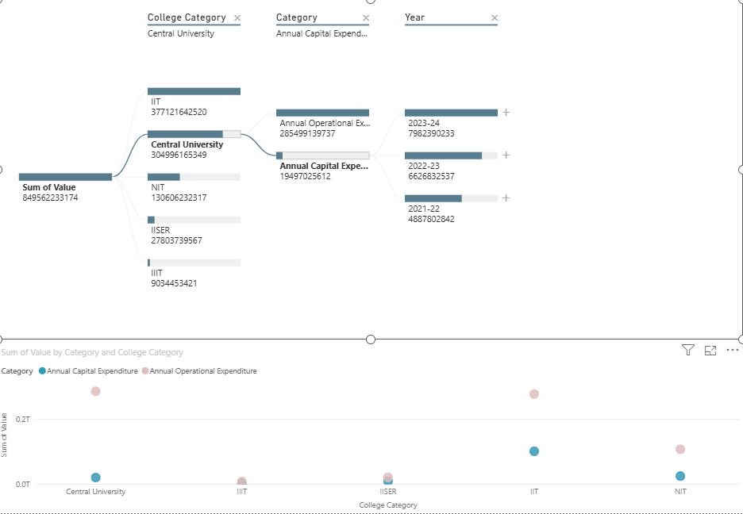
- Total Analyzed Expenditure: ₹849.56 Billion.
- Concentrated Spending: Expenditure is dominated by two institution types, with IITs (44.4%) and Central Universities (35.9%) collectively accounting for over 80% of the total.
- Operational Dominance: Across all categories, Annual Operational Expenditure (e.g., salaries, utilities) is significantly larger than Annual Capital Expenditure (e.g., new equipment, construction).

1.Decomposition Tree Analysis
- Level 1: Institution Spending Breakdown
  - IITs: ₹377.12B
  - Central Universities: ₹304.96B
  - NITs: ₹130.60B
  - IISERs: ₹27.80B
  - IIITs: ₹9.03B
- Level 2: Central University Drill-Down
  - The ₹304.96B for Central Universities is split into:
    - Annual Operational Expenditure: ₹285.50B (93.6%)
    - Annual Capital Expenditure: ₹19.50B (6.4%)
- Level 3: Capital Expenditure Trend (for Central Universities)
  - This visual shows a strong, consistent year-over-year growth in capital investment:
    - 2021-22: ₹4.89B
    - 2022-23: ₹6.63B (+35.6% from prior year)
    - 2023-24: ₹7.98B (+20.4% from prior year)
  - This represents a total 63.4% increase in capital spending from FY 2021-22 to 2023-24.

2.Scatter Plot Analysis
- Primary Insight: Universal Spending Pattern
  - The plot confirms that the operational dominance seen in Central Universities is a universal trend.
  - For every institution type, the Annual Operational Expenditure (pink dot) is an order of magnitude higher than the Annual Capital Expenditure (blue dot).
- Insight 2: Clear Spending Tiers
  - The plot visually groups the institutions into three distinct financial tiers based on their total spending:
    - Tier 1 (High Spend): IITs and Central Universities
    - Tier 2 (Medium Spend): NITs
    - Tier 3 (Low Spend): IISERs and IIITs
1.IISER
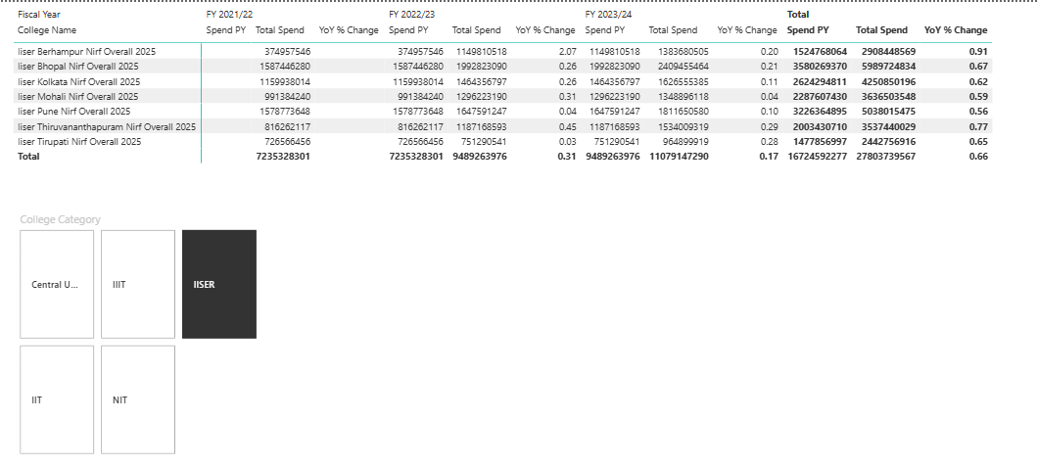
- Largest Spenders (by Total):
  - IISER Bhopal: ₹5.99 Billion
  - IISER Pune: ₹5.03 Billion
  - These two institutions alone account for nearly 40% of the total IISER spend.
- Highest Overall Growth (Total YoY %):
  - 1. IISER Thiruvananthapuram: 77% total growth
  - 2. IISER Berhampur: 91% total growth.
- Key Anomaly: IISER Berhampur (FY 2022/23)
  - This institution saw a massive, anomalous budget increase in FY 2022/23.
  - Its spending jumped from ₹37.4M to ₹114.9M, a 207% increase (YoY % Change of 2.07), before stabilizing in the following year. This suggests a one-time major project or funding allocation.
- Lowest Growth:
  - IISER Pune shows the most modest growth, with a total period increase of 56%. Its annual growth also decelerated sharply from 31% to just 4%.

2.IIIT’s
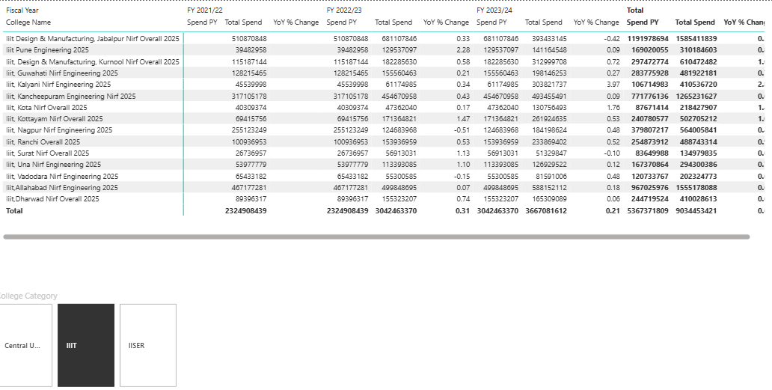
• Largest Spender (by Total):
- Iiit, Kancheepuram is the largest institution by expenditure, with a total three-year spend of ₹12.65 Billion, more than double the next-largest institution (Iiit, Kurnool at ₹6.10 Billion).
• Extreme Volatility in Budgets:
- The data shows extreme year-over-year volatility for many institutions, indicating one-time projects or fluctuating funding.
- Massive Growth Spikes:
  - Iiit, Kalyani: Grew 397% in FY 2023/24 (from ₹61M to ₹303M).
  - Iiit, Kottayam: Grew 147% in FY 2022/23 (from ₹69M to ₹171M).
  - Iiit, Una: Grew 110% in FY 2022/23 (from ₹53M to ₹113M).
- Significant Budget Contractions:
  - Iiit, Nagpur: Shrank by -51% in FY 2022/23.
  - Iiit Design & Manufacturing, Jabalpur: Shrank by -42% in FY 2023/24.

3.NIT’s
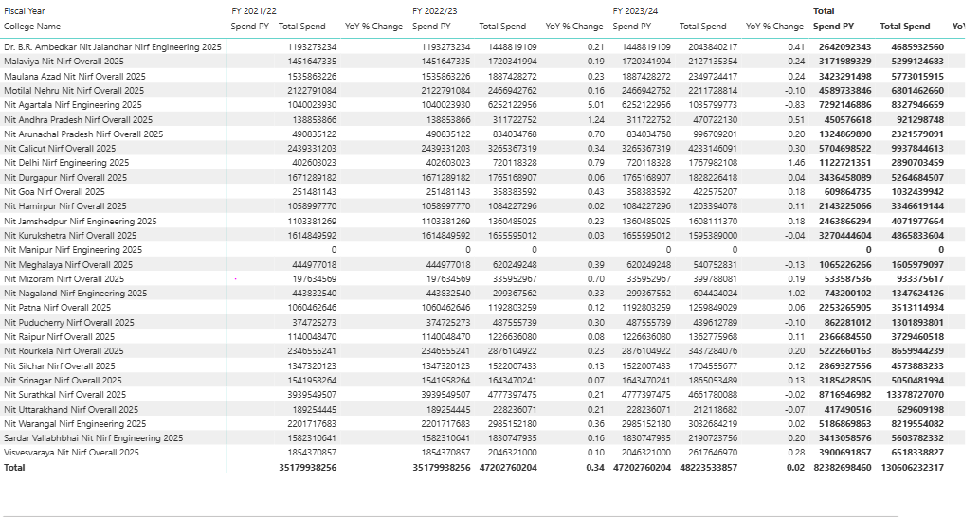
• Largest Spenders (by Total 3-Year Spend):
- 1. NIT Calicut: ₹9.93 Billion
- 2. NIT Rourkela: ₹8.65 Billion
- 3. NIT Agartala: ₹8.32 Billion
• Extreme Budget Volatility:
- Unlike other categories, the NIT budgets show extreme volatility, with massive one-year spikes followed by sharp contractions. This suggests large-scale, non-recurring projects.
- NIT Agartala: Grew by 124% in FY 2022/23, then immediately contracted by -50% in FY 2023/24.
- NIT Andhra Pradesh: Grew by 124% in FY 2022/23, then stabilized at 0.5% growth.
- NIT Goa: Grew by 106% in FY 2022/23, followed by a -28% contraction.
- NIT Puducherry: Showed a massive 119% growth spike in the most recent year (FY 2023/24).

4.IIT’s
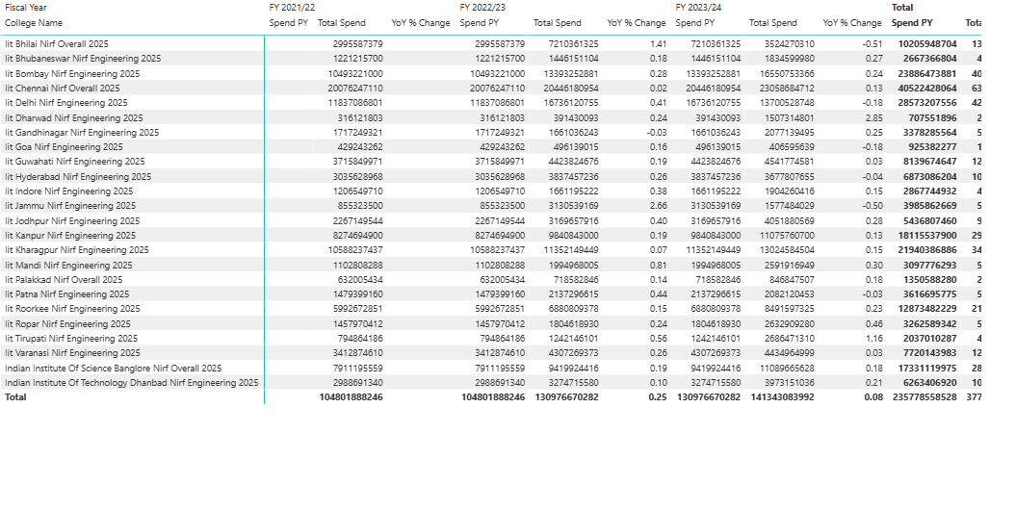
• Top 4 Largest Spenders (by Total 3-Year Spend):
- IIT Madras (Chennai): ₹40.52 Billion
- IIT Delhi: ₹28.53 Billion
- IIT Bombay: ₹23.86 Billion
- IIT Kharagpur: ₹21.94 Billion
- These four institutions alone account for ₹114.85 Billion, or approximately 49% of the entire group's expenditure.
• Extreme Budget Volatility (One-Time Events):
- The data shows several instances of massive, single-year budget changes, suggesting large-scale projects or funding.
- IIT Dhanbad: Showed a massive 285% spending increase in the most recent year (FY 2023/24).
- IIT Jodhpur: Grew by 266% in FY 2022/23, but this was followed by a -50% contraction in FY 2023/24.
- IIT Bhilai: Grew by 141% in FY 2022/23.
- IIT Goa: Experienced a budget contraction of -16% in FY 2022/23.

5.Central Universities
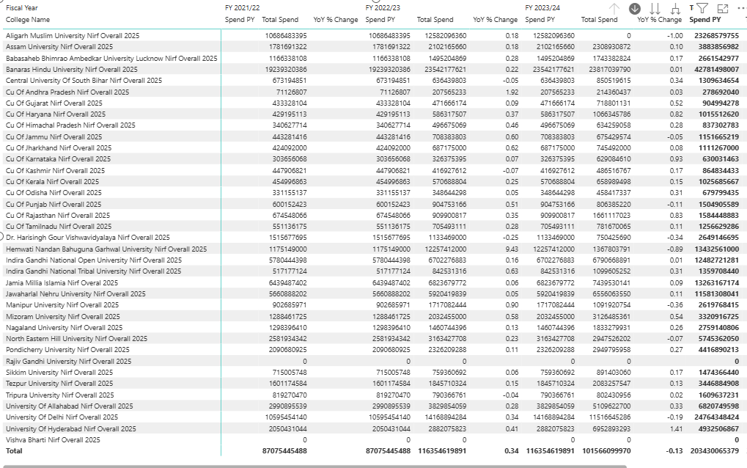
• Top 5 Largest Spenders (by Total 3-Year Spend):
- University of Delhi: ₹49.32 Billion
- Banaras Hindu University: ₹42.78 Billion
- Aligarh Muslim University: ₹38.86 Billion
- Jawaharlal Nehru University: ₹26.15 Billion
- University of Hyderabad: ₹24.76 Billion
• Key Volatility & Trends (FY 2023/24):
- The data shows extreme variance in year-over-year funding changes for individual universities.
- Massive Growth Spike:
  - University of Hyderabad: Experienced a massive 141% budget increase in FY 2023/24.
  - Mizoram University: Grew by 58%.
- Significant Budget Contractions:
  - Hemwati Nandan Bahuguna Garhwal University: Saw a severe budget contraction of -89% in FY 2023/24.
  - Manipur University: Shrank by -36%.
  - Central University of Odisha: Shrank by -31%.

Total spend and % of total spend by category and college category
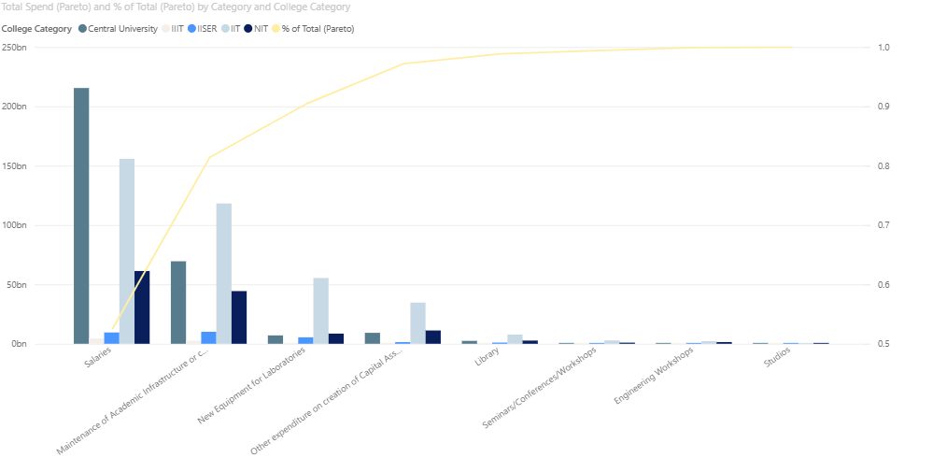

1. The "Vital Few" (The 80%)
- "Salaries": This is the single largest expense category by an enormous margin, totaling over ₹200 Billion.
  - The line chart shows that "Salaries" alone accounts for approximately 70% of all expenditures.
  - The stacked bars show this cost is primarily driven by Central Universities (dark teal) and NITs (light blue).
- "Maintenance of Academic Infrastructure...": This is the second-largest category, at roughly ₹70 Billion.
  - Adding this category brings the cumulative total (the yellow line) to just over the 80% mark (0.8).
  - This cost is also dominated by Central Universities and NITs.

2. The "Trivial Many" (The 20%)
- All remaining categories, such as "New Equipment for Laboratories," "Library," "Seminars," and "Workshops," make up the last 20% of the spend.
- Their bars are significantly smaller, confirming they are not the primary drivers of the overall budget.

3. Key Insight by College Category (From the Stacks)
This chart reveals a crucial difference in spending priorities between institution types:
- Central Universities & NITs: These institutions dominate the two largest categories: "Salaries" and "Maintenance." Their spending profile is heavily weighted toward operational and personnel costs.
- IITs (Dark Blue): The IITs' spending pattern is different. While they have salary costs, their most dominant spending category is "New Equipment for Laboratories."
  - IITs account for the largest portion of this bar, suggesting a budget strategy that prioritizes investment in R&D and high-tech lab assets more than other institution types.

